**ROYAL PRIMARY SCHOOL - MBALE**

**END OF TERM II EXAMINATIONS 2024**

**P.4 INTEGRATED SCIENCE**

*Time allowed: 2 Hours 15 minutes*

Name: ......................................................................................................................

**SECTION A (40MARKS)**

1. Name any one domestic animal that gives us milk.

………………………………………………………………………………………………………………………………

1. How are the ears useful to a dog?

………………………………………………………………………………………………………………………………

1. State any one role of a mother in a home.

……………………………………………………………………………………………………………………………….

1. Which gas is needed by seeds to germinate?

……………………………………………………………………………………………………………………………….

1. How many legs has a spider?

………………………………………………………………………………………………………………………………..

1. Give the use of the body organ marked Y on the diagram below.

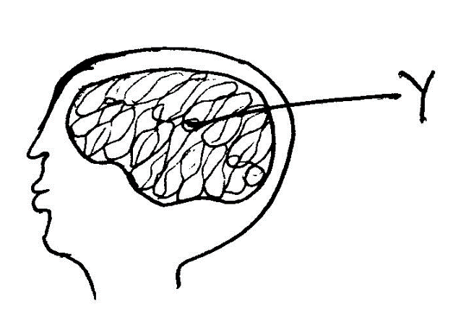……………………………………………………………………….

1. State any one way of caring for crops in the garden.

………………………………………………………………………………………………………………………………

1. Identify any one component of air.

……………………………………………………………………………………………………………………………….

1. Apart from a hen, name one other domestic bird.

………………………………………………………………………………………………………………………………

Use the diagram below to answer questions 10.

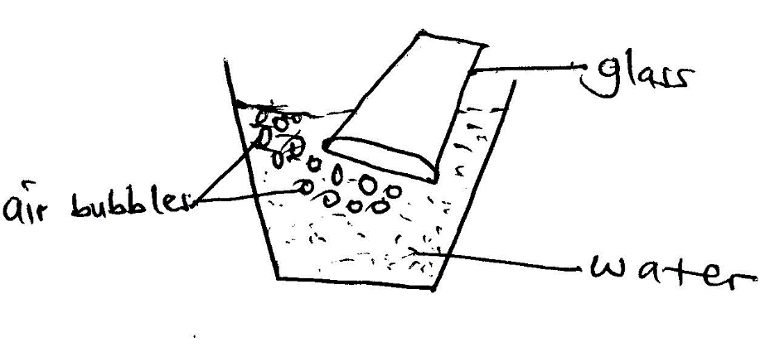

1. Name the property of air shown above.

………………………………………………………………………………………………………………………………..

1. Mention any one example of a deficiency disease.

………………………………………………………………………………………………………………………………..

1. Give any one use of water at home.

…………………………………………………………………………………………………………………………….....

1. Apart from refrigerating, give any one way of preserving food.

………………………………………………………………………………………………………………………………..

1. Give any one material that people may use to clean their teeth.

…………………………………………………………………………………………………………………………………

1. Name the sense organ for tasting food.

………………………………………………………………………………………………………………………………..

1. Why do bees visit flowers?

………………………………………………………………………………………………………………………………...

1. Write any one use of food in the body.

………………………………………………………………………………………………………………………………..

The diagram below is of a human tooth. Study it and answer question number 18.

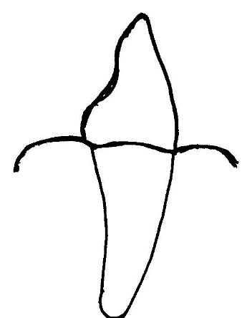

1. Name the type of tooth shown above

………………………………………………………………………………..………………………………………………

1. Identify the type of soil suitable for crop growing.

……………………………………………………………………………………………………………………………….

1. Suggest any one reason why people eat food.

……………………………………………………………………………………………………………………………….

1. Mention any one activity a farmer carries out during the wet season.

……………………………………………………………………………………………………………………………….

1. Which food value can someone get when he/she eats an egg?

……………………………………………………………………………………………………………………………….

1. Name the male reproductive part of a flowering plant.

………………………………………………………………………………………………………………………………..

1. Which element of weather do people use for winnowing?

………………………………………………………………………………………………………………………………..

1. Identify the deficiency disease caused due to lack of carbohydrates.

………………………………………………………………………………………………………………………………..

1. Write one type of germination.

………………………………………………………………………………………………………………………………..

1. Give one function of the organ below.

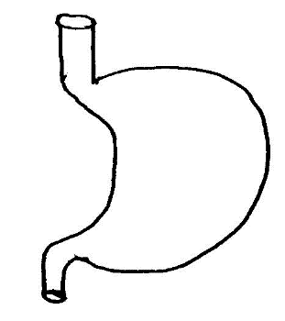…………………………………………………………………………………………..

1. Name any one material that can be used to build a house.

………………………………………………………………………………………………………………………………..

1. How is a pit latrine useful in a school?

…………………………………………………………………..……………………………………………………………

1. Which type of clouds is a clear sign of rain?

……………………………………………………………………………………………………………………………….

1. State the type of soil used for making pots.

……………………………………………………………………………………………………………………………….

1. Why should people wash fruits before eating them?

………………………………………………………………………………………………………………………………..

1. Which animal stays in the habitat shown?

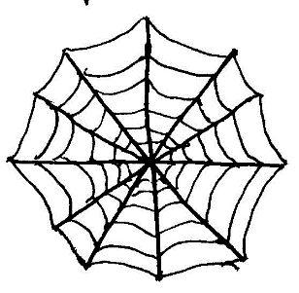………………………………………………………………………………………………

1. Name the main source of water in the environment.

…………………………………………………………………………………………………………………………………..

1. State the role of chlorophyll during photosynthesis.

……………………………………………………………………………………………………………………………….

1. Why do animals move from one place to another?

……………………………………………………………………………………………………………………………….

1. Mention any one use of electricity in a home.

……………………………………………………….……………………………………………………………………….

1. Define the term air.

………………………………………………………………………………………………………………………………

1. State any one way of keeping our bodies clean.

………………………………………………………………………………………………………………………………

1. How can we keep our food from getting contaminated?

……………………………………………………………………………………………………………………………….

**SECTION B (60 MARKS)**

1. a) Identify the domestic animal which is kept for security.

…………………………………………………………………………………………………………………………………

b) What do we call the young ones of the following animals?

i) dog ………………………………………………………………………………….

ii) cow …………………………………………………………………………………

iii) pig …………………………………………………………………………………

1. The diagram below shows a split bean seed. Use it to answer questions that follow.

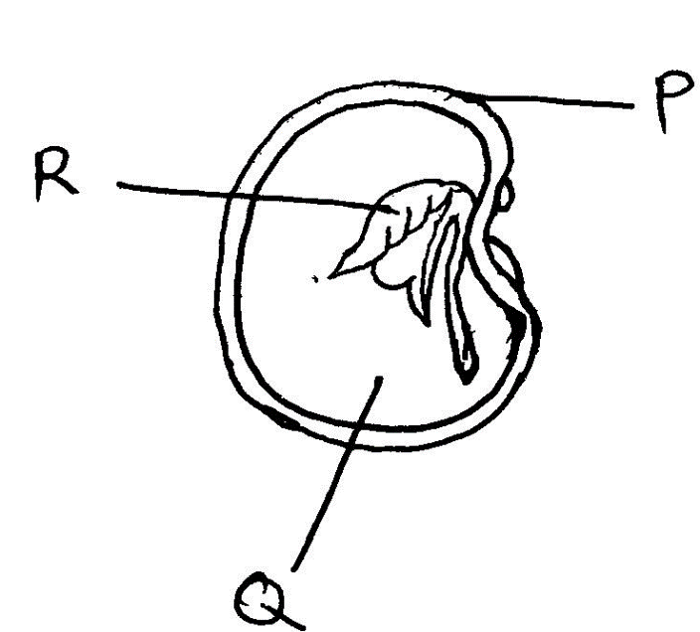

a) Name parts marked Q and R.

Q………………………………………………………………………………………………………………………………R……………………………………………………………………………………………………………….………………

b) Give the function of part marked P

…..………………………………………………………………………………………………………………………………

c) Which type of germination does the bean seed above undergo?

………………………………………………………………………………………………………………………………….

1. Give any two food values that make up a balanced diet.

………………………………..…………………………………………………………………………………………………

1. Mention any two places where people get food.

……………………………………………………………………………………………………………………………

1. a) Name the garden tools below.

………………………………………………………………………

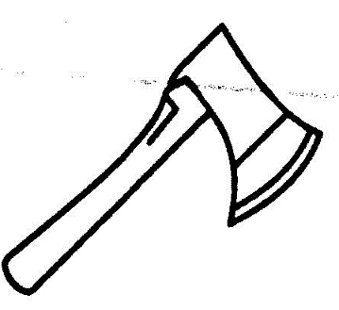………………………………………………………………………

b) Give any two ways of caring for garden tools.

……………….. ………………………………………………………………………………………………………………..

1. a) What name is given to the food made by plants during photosynthesis?

………………………………………………………………………………………………………………………………..

b) Mention any two conditions needed by plants to make their own food.

i) ………………………………………………………….ii) ………………………………………………………………..

c) Why are plants not able to make their own food at night?

………………………………………………………………………………………………………………………………….

1. a) Define the term pollination.

………………………………………………………………………………………………………………………………………………………………………………………………………………………..……………………………………………

b) State any two types of pollination

i) ……………………………………………………………………………………………………………………………..

ii) …………………………………………………………………………………………………………………………….

c) Name the insect that pollinates flowers at night.

….……………………………………………………………………………………………………………………………..

1. a) Name the body part that protects the brain.

………………….………………………………………………………………………………………………………………

b) Give the function of each of the following.

i) kidney…………………………………………………………………………………………………………………….

ii) heart……………………………………………………………………………………………………………………..

iii) skin ……………………………………………………………………………………………………………………..

1. a) List down any two materials used in cleaning our bodies.
2. …………………………………………………………………………………………………………………………
3. …………………………………………………………………………………………………………………………
4. Give any one example of the skin disease.
5. …………………………………………………………………………………………………………………………
6. Suggest any one way of caring for our skin.

………………………………………………………………………………………………………………………

1. The diagram below shows weather instruments.

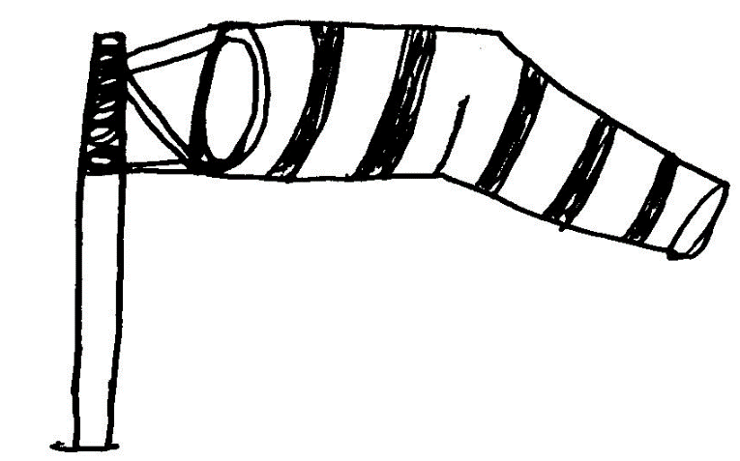

a) Name the instrument shown above.

…………………………………………………………………………………………………………………………………

b) Which element of weather enables the instruments above to work?

………………………………………………………………………………………………………………………………..

c) Mention any two elements of weather.

i) …………………………………………………………………………………………………………………………..

ii) …………………………………………………………………………………………………………………………

1. a) Name two types of leaves.
2. ……………………………………………………………………………………………………………………
3. ..………………………………………………………………………………………………………………….

b) State any two importance of leaves to plants.

i) ……………………………………………………………………………………………………………………………..

ii) ……………………………………………………………………………………………………………………………..

1. a) Give he difference between wind and air.

…………………………………………………………………………………………………………………………………………………………..………………………………………………………………………………………………

b) State any two properties of air.

i) …………………………………………………………………………………………………………………………..

ii) …………………………………………………………………………………………………………………………

c) Which gas helps burning to take place?

……………………………………………………………………………………………………………………………

1. a) Define the term mulching.

…………………………………………………………………………………………………………………………………………………………………………………………………………………………………………………………

b) Mention any two examples of mulches used for mulching.

i) ……………….……………………………………………………………………………………………………

ii) ……………………………………………………………………………………………………………………

c) State any one advantage of mulching the garden.

………………………………….……………………………………………………………………………………..

1. a) Name any two living things found in soil.
2. …………………………………………………………………………………………………………………………
3. ………………………………………………………………………………………………………………………

b) Mention any two materials made from clay soil.

i) ………………………………………………………………………………………………………………

ii) …………………………………………………………………………………………………………….

1. a) Name two types of teeth.
2. ……………………………………………………………………………………………………………………
3. ……………………………………………………………………………………………………………………

b) Give the function of the following type of teeth.

i) incisors…………………………………………………………………………………………………………

ii) canines …………………………………………………………………………………………………………..

1. Which domestic animal is kept for security at home?

……………………………………………………………………………………………………………………………

1. Match the animals in A with their habitats in B correctly.

A B

**Animal Habitat**

bird hutch

dog nest

rabbit kraal

cow kennel

1. bird……………………………………………………………………………………………..…………..
2. dog………………………………………………………………………………………….…..…………..
3. cow……………………………………………………………………………………….…..…..………..
4. rabbit………………………………………………………………………………………..……………..

**END**

**WISH YOU SUCCESS**